

|  |  |  |  |  |  |
| --- | --- | --- | --- | --- | --- |
| Programme | : | **M.Tech. (SE)** | Semester | : | **Fall 20-21** |
| Course | : | **Advanced Database Management Systems (Embedded Lab)** | Code | : | **SWE2014** |
| Faculty | : | **Dr.Bhuvaneswari A** | Slot | : | **L43 + L44** |
| Ex. No. | : | **7** | Date | : | **01.09.2020** |

**NAME : KANDULA NAVEEN KUMAR**

**REG: 17MIS1056**

**Advanced SQL – Active Database**

1. **Consider the table Employee**

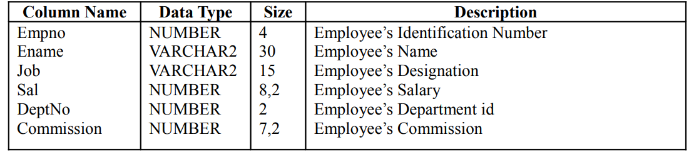

1. Create table and Insert five appropriate records into the Employee table.

ANS:

create table Employee(

Empn0 number(4) primary key,

Ename varchar2(30),

Job varchar2(15),

Sal number(20),

Deptno number(20),

Commision number(30));

**INSERTION:**

insert into Employee values(1001,'naveen','S',25000,12,2);

insert into Employee values(1002,'trinay','DE',35000,14,16);

insert into Employee values(1003,'mounisha','HE',45000,13,17);

insert into Employee values(1004,'hemanth','KE',85000,10,22);

insert into Employee values(1005,'sandeep','LE',55000,18,20);

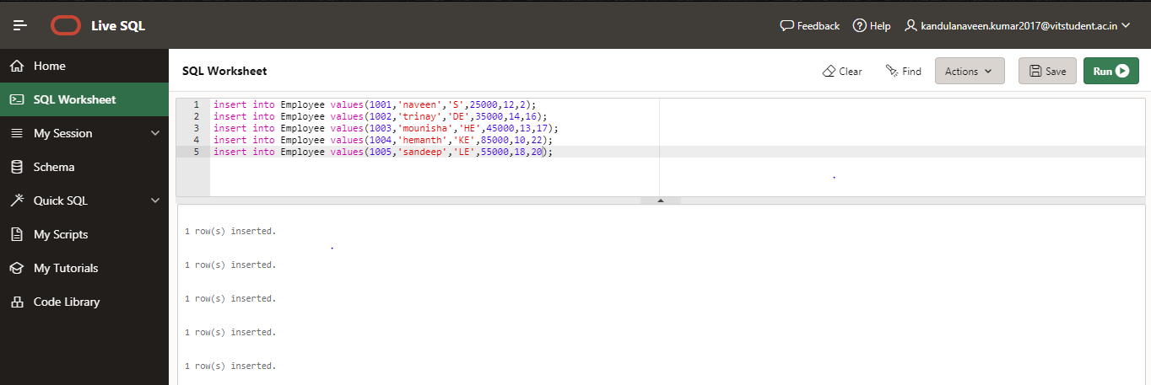

1. Handling Multiple DML commands

a.If updating, trigger a message “Updating the table” in sql prompt.

b.If inserting, trigger a message “Inserting new row into the table” in sql prompt.

c. If deleting, trigger a message “Deleting the table” in sql prompt.

ANS:

create trigger NA

before update or insert or delete on Employee

For each row

Begin

if Updating then

DBMS_OUTPUT.PUT_LINE('Updating the table');

elsif inserting then

DBMS_OUTPUT.PUT_LINE('Inserting the table');

elsif deleting then

DBMS_OUTPUT.PUT_LINE('Deleting the table');

end if;

end;

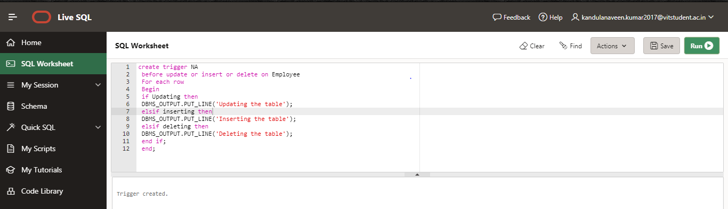

1. Write a trigger called SAL_CHECK on table salary column does not allow the insertion or update of any record more than 10,000 (salary column)

ANS:

create trigger SAL_CHECK

before update or insert on Employee

for each row

declare

Sal number(20);

begin

if inserting then

if (:old.Sal<1000) then

RAISE_APPLICATION_ERROR(-20004, 'Cannot insert record.');

end if;

elsif updating then

if (:old.Sal<1000) then

RAISE_APPLICATION_ERROR(-20004, 'Cannot Update record.');

end if;

End IF;

End;

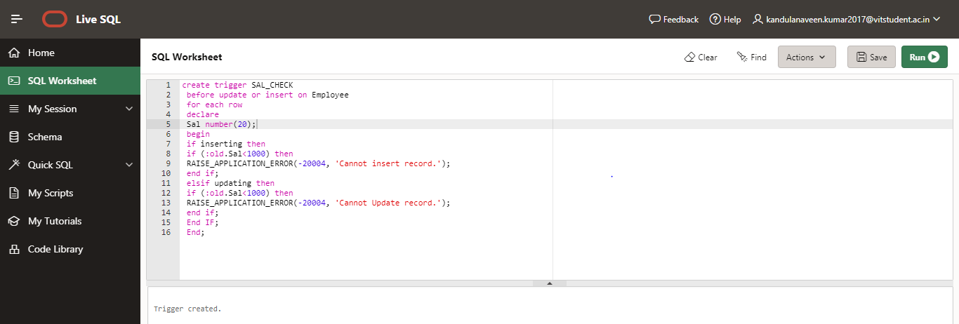

1. Write a trigger to Give 10% raise to all employees whose salary < 1000.

ANS:

create trigger JK

before insert or update of Sal on Employee

for each row

begin

if :new.Sal<1000 then

:new.Sal:=0.1*:new.Sal;

Dbms_output.put_line('Salaries are Updated');

end if;

end;

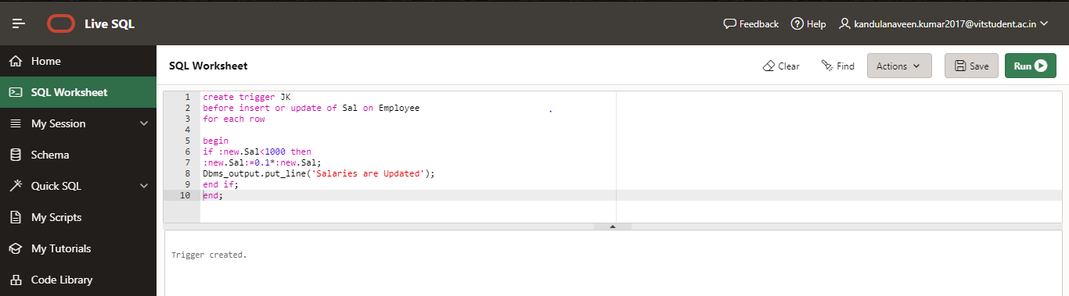

1. For given table, create “Before Update” trigger preventing any update on Primary Key column.

ANS:

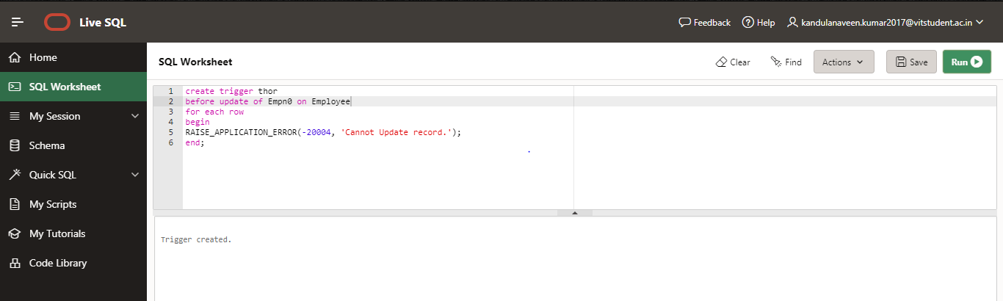

1. Write a statement level trigger to Store the count of employees having salary > 4000 in new EmpCount Table.

ANS:

create table EmpCount(

cnt number(20));

Create Trigger mou

After Insert Or Update of Sal On Employee

Begin

delete from EmpCount;

insert into EmpCount(cnt) Select count(*) from Employee where Sal >4000;

End;

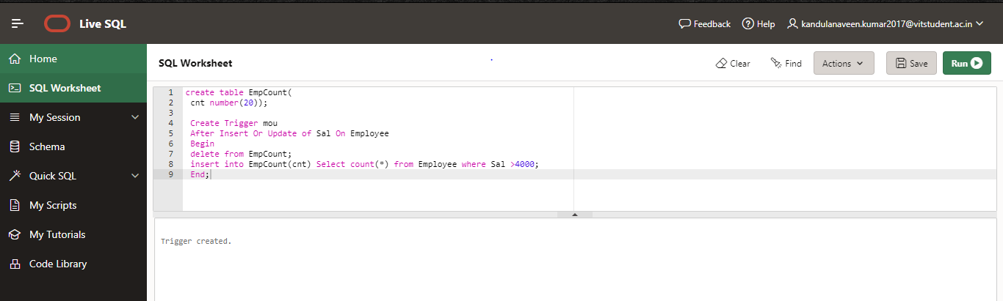

1. Whenever an Employee is resigned from the company, his details should be deleted and moved to EMPLOYEE HISTORY table. Write a trigger to insert the deleted details from Employee table into EMPLOYEE HISTORY table with following details : DB User (who deleted the employee), Empno, Job, Ename, sysdate,

ANS:

create table Empy_Hist(

Empn0 number(4) primary key,

Ename varchar2(30),

Job varchar2(15),

User_id varchar2(30) );

create trigger HE

after insert or delete on Employee

for each row

begin

insert into Empy_Hist

(Ename,EmpN0,job)

values(:old.Ename,:old.Empn0,:old.Job);

end;

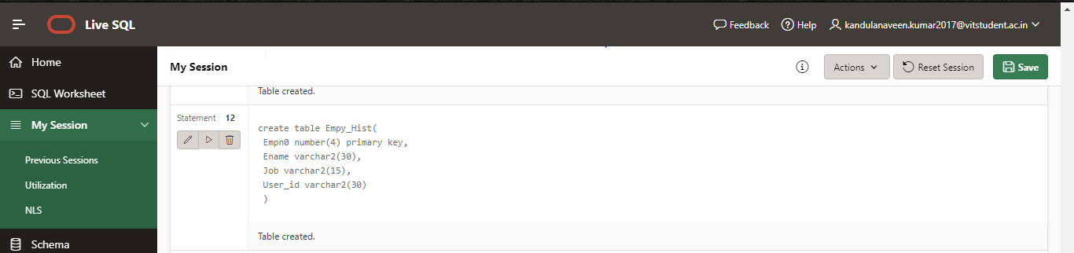

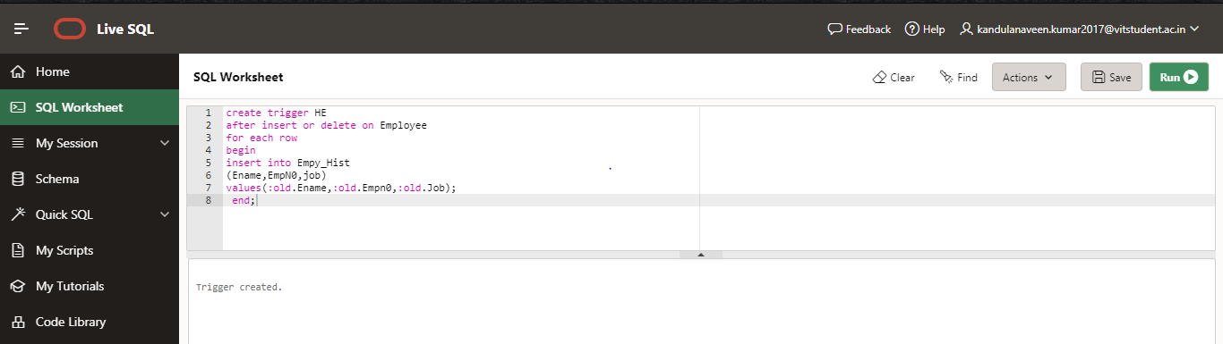

1. Fire a statement trigger, that checks the time of update against the Employee table and rejects any update between 4 PM to 7 PM. (Use SYSDATE)

ANS:

create trigger su

before delete or update or insert on Employee

begin if to_char(sysdate,'hh24')>'16' or

to_char(sysdate,'hh24')<'19' then

RAISE_APPLICATION_ERROR(-20004, 'Cannot Update record.');

end if;

end;

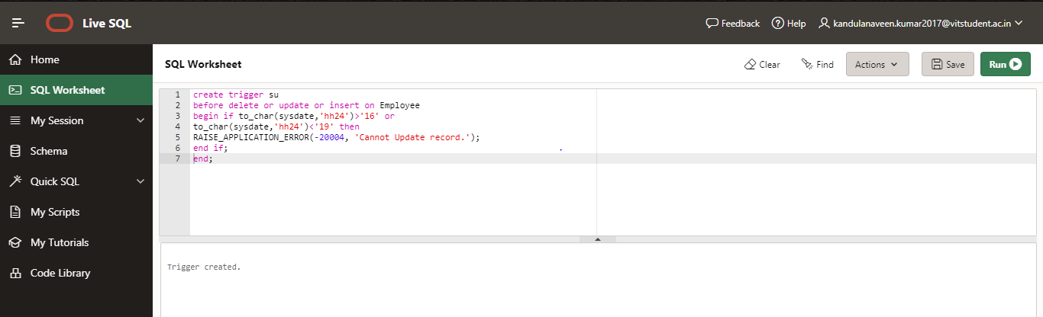

1. Fire a statement trigger, that checks the day of update against the Employee table and rejects any update on SUNDAY.

ANS:

create trigger sri

before insert or delete or update on Employee

for each row

begin

if to_char(sysdate,'dy') = 'Sun' then

dbms_output.put_line('cannot be updated on sunday');

end if;

end;

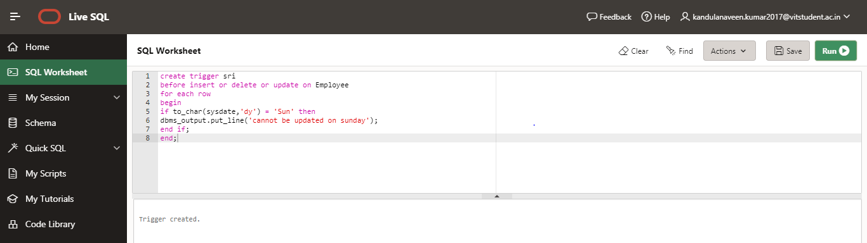

USEFUL REFERENCE :

* <http://www.exforsys.com/tutorials/oracle-9i/oracle-database-triggers.html>
* <https://www.tutorialspoint.com/plsql/pdf/plsql_triggers.pdf>
* <http://myweb.cmu.ac.th/rattasit.s/CS204726/Assignment/Assignment%206%20-%20Stored%20Procedure/Oracle%20Triggers.pdf>